UNITED STATES MILITARY ACADEMY

PROJECT ANALYSIS

XE401

SECTION H1

LTC FINOCCHARIO

By

CADET THOMAS D. GOVER ’22, CO B4

CADET FINNIAN VALLE ‘22 CO G4

CADET CASPAR PLACKE ‘22 CO H3

CADET ALEXANDER NGUYEN ‘22 G3

CADET ABDELAZIZ GOHAR ‘22 CO H3

WEST POINT, NEW YORK

3NOV2021

___ MY DOCUMENT IDENTIFIES ALL SOURCES USED AND ASSISTANCE

RECEIVED IN COMPLETING THIS ASSIGNMENT.

TG, FV, CP, AN, AG I DID NOT USE ANY SOURCES OR ASSISTANCE REQUIRING

DOCUMENTATION IN COMPLETING THIS ASSIGNMENT.

SIGNATURE: Thomas Gover, Finnian Valle, Caspar Placke, Alexander Nguyen,

Abdelaziz Gohar

Our project at a high level consists of creating the central control unit of a cube satellite

that will accompany a larger military satellite and assist in defense and gathering sensor

information by co-orbiting with the larger military satellite. With the central control unit of the

CubeSat, our system will operate so that our product owner can attach payloads as specified by the product owner (examples include subsystems which handle coordination with nearby satellites, and other subsystems that will be developed by follow-on projects). These CubeSats will be constantly collecting data about the conditions around them and position data that will be sent back in a data stream to the ground station. A key feature of our product will be its universality as we intend for our central control system to be used for multiple sub-models of CubeSats.

In addition to the physical structure of our cube satellite, our CubeSat will include a few

key subsystems. This will include a command data handling system, a communication system, a telemetry and tracking system, and a power system. The protocols our system will use will be

I2C between CPU, power, and temperature, UART between the CPU and GPS, and SPI between the CPU and the telecommunication system. These protocols were selected because they are all compatible with Raspberry Pis which we are selecting as our CPU. All these subsystems will be accessed through the command line as our user interface.

There are four blocks in our block diagram. There is the computer subsystems, which have the CPU’s of the satellite and some basic sensors, there's the power subsystem which has the battery and the power collection panels which will handle collection, storage, and distribution of power, theres the gps subsystem which contains the GPS, and then there's the communication subsystem which contains our transceiver which will handle sending and receiving data.

For the computer subsystem there will be two CPU’s which can each reset each other, a telemetry tracking unit, a temperature unit, and an altitude unit. These will all be supplied power at 5v from the power bus in the block. It will take input from the other subsystems in the form of data packets from the communication array, power system status from the power subsystem, and GPS data from the GPS subsystem. It will send out data packets to the communication subsystem, and requests for data to be sent to the power and GPS subsystems. The GPS subsystem will be responsible for collecting and sending GPS data to the CPU its inputs will be a send data signal from the computer subsystem and its outputs will be GPS data. The communication subsystem will receive data packets from the CPU and commands from the ground station and will output data packets from the ground station and to the CPU.

The power system has the solar panels, the power converter and the batteries. The solar panels will serve as the primary source of power to the cubesat components, while charging the batteries. The batteries will work only when the solar panels are not providing low or no power. The solar panels will be routed to a power regulator to provide two buses of outputs (3.3 and 5 v). Finally, the power subsystem will have a telemetry to measure current and voltage.

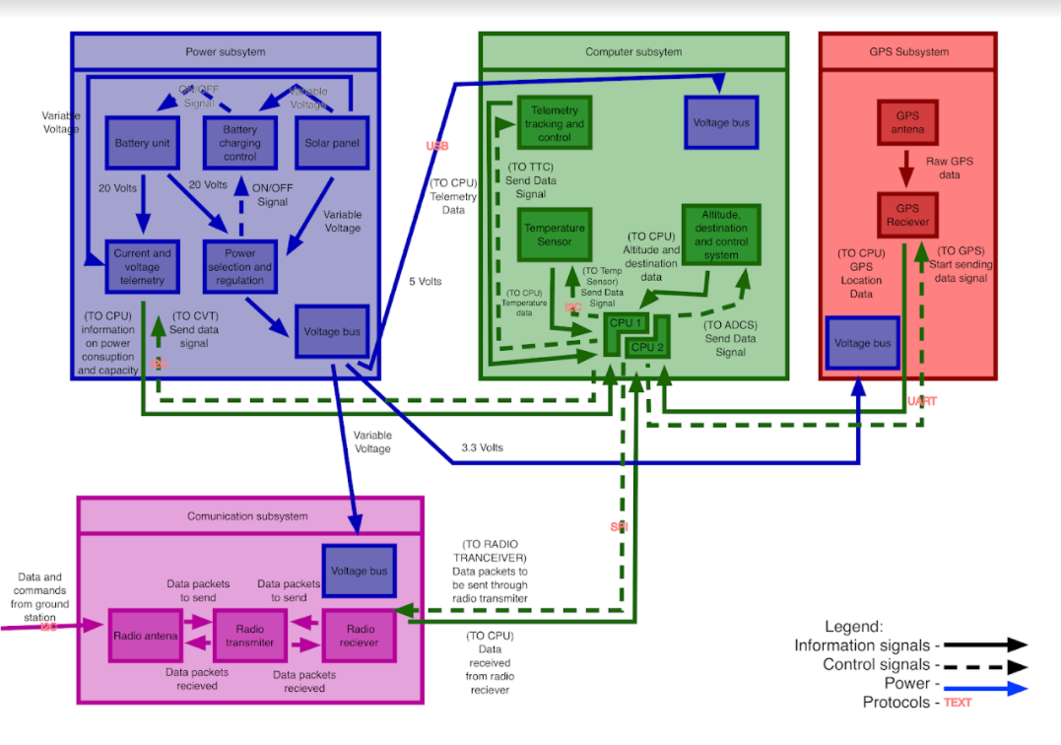

This block diagram hits on a lot of specifications and constraints. Spatially, our components together with brackets and wires takes up an estimated 70% of the 1U space allotment, leaving plenty of space for add-on payloads developed by future projects. As far as modularity with payloads is concerned, the three different busses (5, 3.3, and variable volt busses) allow for a lot of flexibility as far as payload power requirements are concerned. This fits with our test payloads of thermometers and LED lights, as well as any future payloads. Additionally, the communications subsystem is able to handle data streams via input from the CPU that will include data packets from the GPS subsystem, the power subsystem, and payload packets which will all be routed through our CPUs. The communications subsystem additionally has the capability to communicate with each CPU as shown in the diagram. The computer subsystem includes a dual-CPU feature with connections which enable each to restart one another (we will use a dedicated port connected to the opposite CPU which is set LO that we can tell the opposite CPU to send out a HI signal and restart the other one).